Report On: Microsoft Certification on Machine Learning Webinar

- Held on: July 28, 2020
- Time: 01:00PM to 02:00PM
- Online Platform: GoToMeeting
- Resource Person: Mr. Deepak Garg
- Designation: Spokesperson, ATS Learning Solutions

ATS Learning Solutions organised a webinar under the banner of ABIT on “Microsoft Certification on Machine Learning” which was specially targeted towards students from the Third and Final Year Engineering from Information Technology and Computer Engineering departments. As the shutdown due to the global pandemic leaves the students with a lot of time on their hands apart from the online lectures being conducted by the institute, they were really excited about getting to learn some insights on how they could make good use of this excessive time and open themselves to exciting opportunities.
Students who were interested in attending the seminar were asked to fill up a form provided by ATS Learning Solutions and these students were later added to a WhatsApp group created by the organisers for effective communication. Further instructions and details about how to join the webinar were given on the group.
The webinar started with Mr. Garg enlightening the students with importance of machine learning in the real world and how these new age skills will help the overall development of a student’s profile and skills. He, then, went on to explain how to students can develop their skills according to the latest trends in technology and, thus, make their profile stand out from the others.
The speaker then introduced the students with various programs offered by ATS Learning Solutions to help students get hands on experience with machine learning using Python. The speaker stressed on the “practical oriented training” and “learn by doing” aspects of their training programs. Later, he explained the curriculum of the programs offered in detail and went on to show some certificates and score cards of students who have successfully completed the training programs.
All this material including testimonies from past students, their score cards and certificates, the curriculum, etc. were shared on the WhatsApp group. About 250 students attended the webinar which was the maximum capacity permitted by GoToWebinar for one single meeting. Students were really intrigued and wanted to know more about the training programs. Looking at the enthusiasm of the students, ATS Learning Solutions announced that the students who enrol early will receive special discounts.
The session was indeed informative, and an eye opener for students who didn’t have a clear idea about importance of machine learning and the training programs provided to learn the same. Thus, it ended on a positive note.

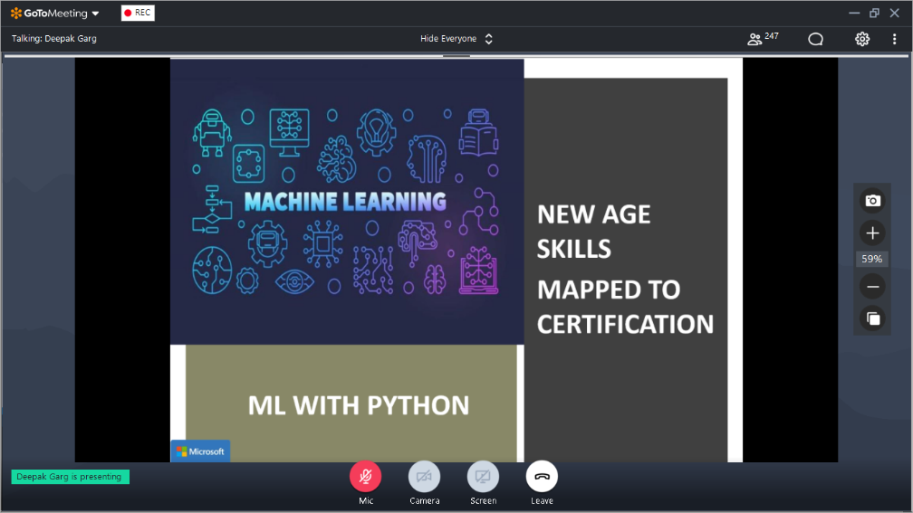

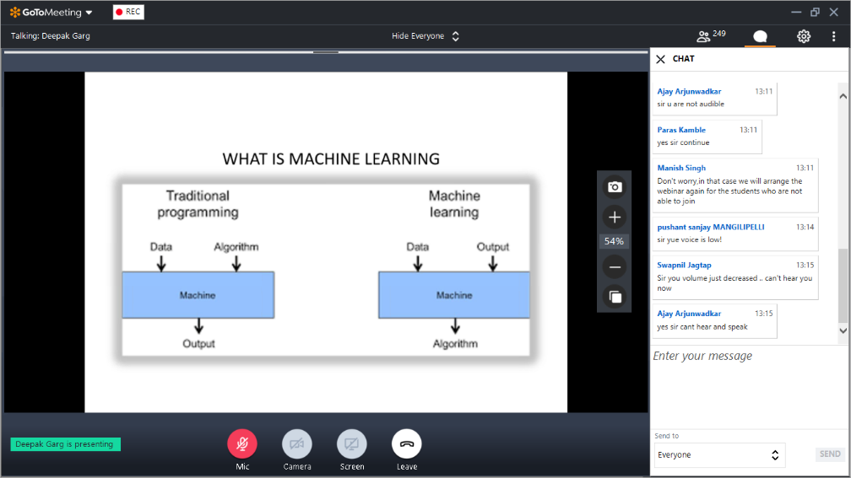

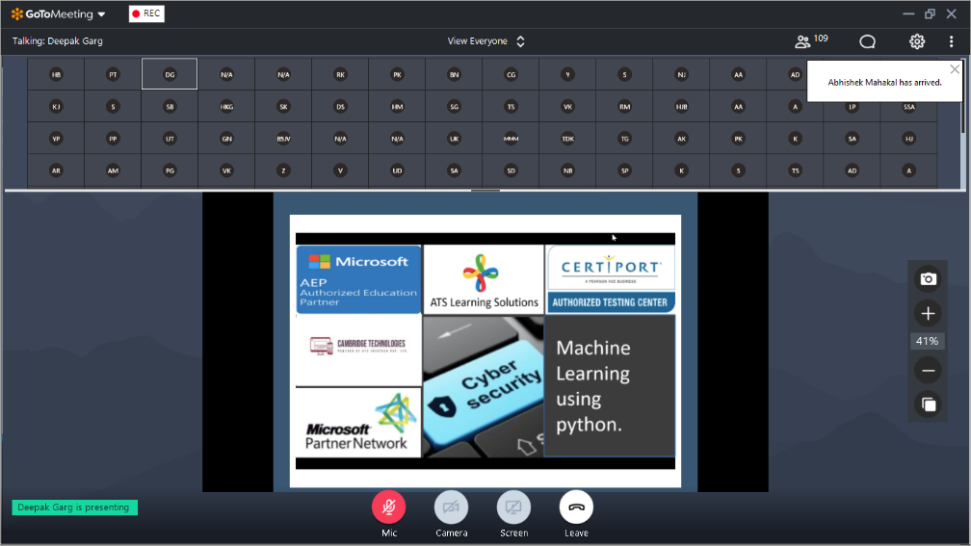

_________________ | _________________ | _________________
Ms. Siddhika Tibarewala  President  ABIT, RGIT | Prof. Nilesh Rathod  Student Convener  ABIT, RGIT | Dr. S.B. Wankhade  H.O.D.  IT Department, RGIT

